# JAVA PROGRAMMING LANGUAGE

UNIT-1

LAB ASSIGNMENT-1

(C_48_LAB_ASSIGNMENT_1)

1. Write a program to print your first_name, middle_name, Last_name, DOB, class, Div,

contact_number, email_id.

CODE : */*1. Write a program to print your first_name, middle_name, Last_name, DOB, class, Div,*

*contact_number, email_id.*/*

class **p1_Personal_Details**

{ public static void **main**(**String**[] args)

    {

**System**.out.**println**("First Name: Pansuriya");

**System**.out.**println**("Middle name: jaimin");

**System**.out.**println**("Last name: pravinbhai");

**System**.out.**println**(" DOB:

1-5-2006");

**System**.out.**println**("Class Name: BCA");

**System**.out.**println**("Division: C");

**System**.out.**println**("Contact Number: 9327589322");

**System**.out.**println**("E-Mail :bca2023jaiminkumar915@tnraocollege.org");

    }

}

**OUTPUT:**

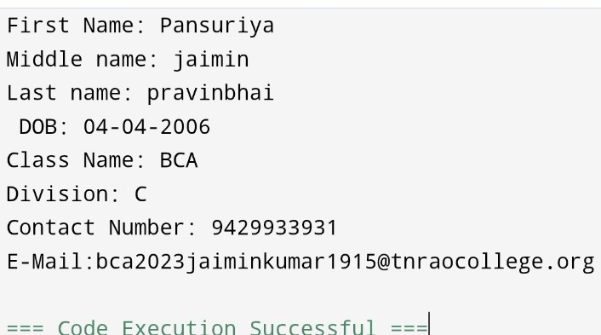

________________________________________________________________________________

2. Write a program to demonstrate all data types.

________________________________________________________________________________

CODE :

*/*2. Write a program to demonstrate all data types.*/*

class **p2_Data_Types**

{

    public static void **main**(String[] args)

    {

        int var1=100;

        short var2=5;

        byte var3=1;

        long var4=132;

        boolean bool_var1=true;

       boolean bool_var2=false;

        char char_var='D';

        String str_var="KANPARIY Dharul";

        float f_var=32.65f;

        double d_var=543.34d;

        System.out.**println**("Integer Variable is :"+var1);

        System.out.**println**("(Integer)Short Variable is :"+var2);

        System.out.**println**("(Integer)Byte Variable is :"+var3);

        System.out.**println**("(Integer)long Variable is :"+var4);

       System.out.**println**("Boolean Variable is :"+bool_var1);

       System.out.**println**("Boolean Variable is :"+bool_var2);

        System.out.**println**("Char Variable is :"+char_var);

        System.out.**println**("string Variable is :"+str_var);

        System.out.**println**("Float Variable is :"+f_var);

        System.out.**println**("Boolean Variable is :"+d_var);

    }

}

__________________________________________________________________________________________________________________________________________________________________

# OUTPUT:

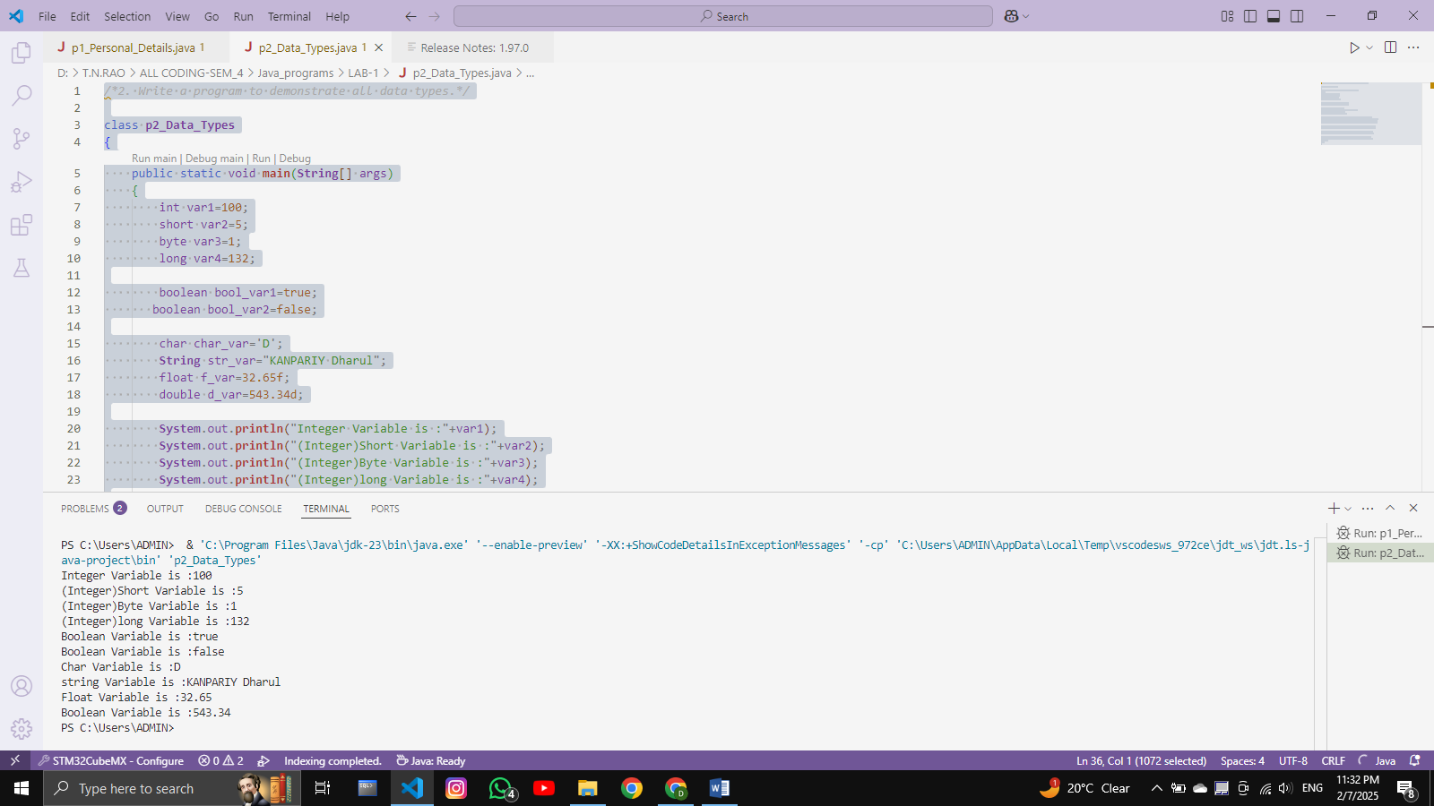

______________________________________________________________________________________________________

3. Write a program to demonstrate all types of literals.

________________________________________________________________________________

CODE:

class **p3_literals**

{

    public static void **main**(**String** args[])

    {

        int count = 498;

        float floatValue = 3.14f;

        double doubleValue = 56.4159d;

        int hexval = 0x6F;

        int binary = 0b100010;

        int octalval = 075;

        char alpha = 'N';

**String** str = "String value";

        boolean boolval = true;

**String** StruName = null;

        char ch1 = '\u0031';

        char ch2 = 1846;

**System**.out.**println**("Integer Literal: " + count);

**System**.out.**println**("Float Literal: " + floatValue);

**System**.out.**println**("Double Literal: " + doubleValue);

**System**.out.**println**("Hexadecimal Literal: " + hexval);

**System**.out.**println**("Binary Literal: " + binary);

**System**.out.**println**("Octal Literal: " + octalval);

**System**.out.**println**("Character Literal: " + alpha);

**System**.out.**println**("String Literal: " + str);

**System**.out.**println**("Boolean Literal: " + boolval);

**System**.out.**println**("String Literal: " + StruName);

**System**.out.**println**("Character Literal: " + ch1);

**System**.out.**println**("Character Literal: " + ch2);

**System**.out.**println**("\t" + "Backslash");

    }

}

# ___________________________________________

# OUTPUT :

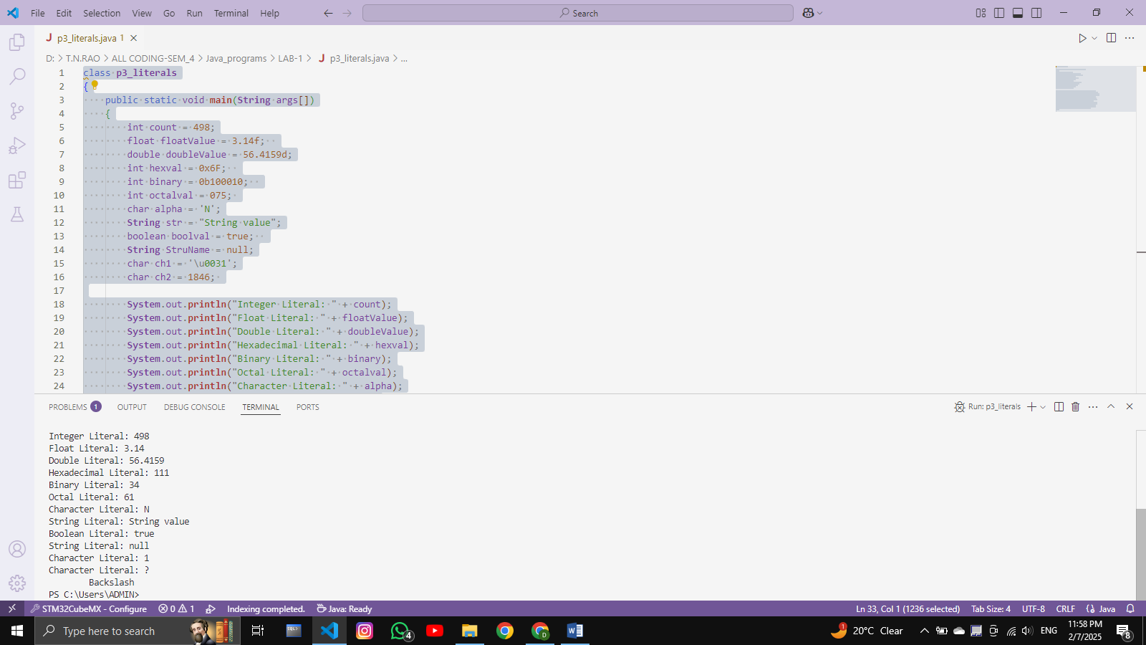

_____________________________________________________________________

4. Write a program to calculate area of circle.

______________________________________________________________________CODE :

______________________________________________________________________

*//4. Write a program to calculate area of circle.*

class **p4_Area_of_circle**

{

    public static void **main**(**String**[] args)

    {

        double pie=3.14;

        double radious=12;

**System**.out.**println**("Area of circule :"+(pie*radious*radious));

    }

}

______________________________________________________________________OUTPUT :

___________________________________________

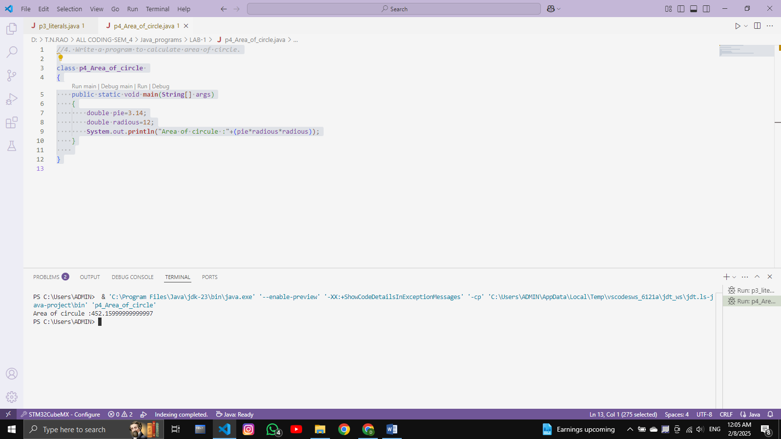

________________________________________________________

5. Write a program to perform all arithmetic operations. (+, - ,*, /, %) .

CODE :

*//5. Write a program to perform all arithmetic operations. (+, - ,*, /, %)*

class **p5_Arith_operation**

    {

    public static void **main**(**String**[] args) {

          double a=10d,b=20d;

**System**.out.**println**("Addtion of " +a +"+"+ b +":"+(a +b));

**System**.out.**println**("Substraction of " +a +"-"+ b +":"+(a -b));

**System**.out.**println**("Multiplication of " +a +"*"+ b +":"+(a *b));

**System**.out.**println**("Division of " +a +"/"+ b +":"+(a /b));

**System**.out.**println**("Module of " +a +"%"+ b+ ":"+(a %b));

        }

    }

______________________________________________________________________OUTPUT :

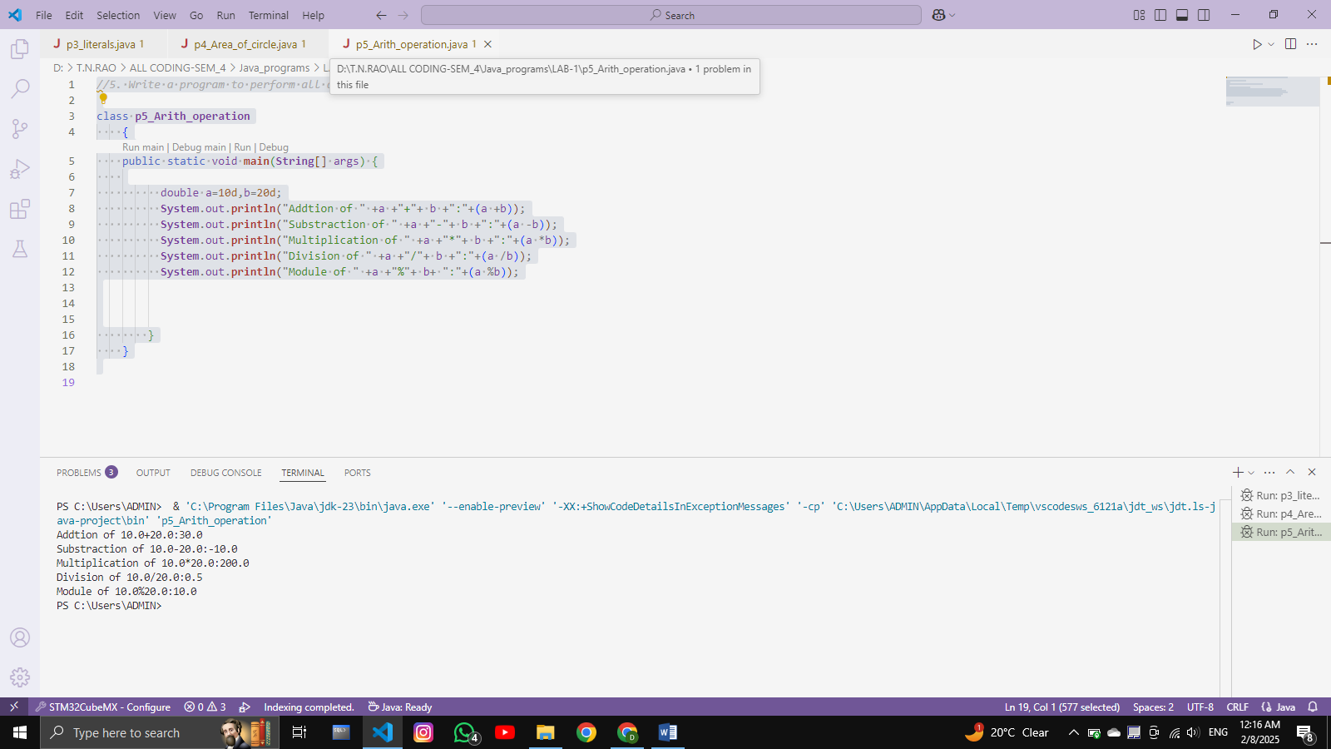

6. Write a program to calculate area of triangle.

CODE :

*//6. Write a program to calculate area of triangle.*

class **p6_area_of_triangle**

{

    public static void **main**(**String**[] args)

    {

        double Base=32;

        double height=65;

        double area_of_triangle=(Base*height)/2;

**System**.out.**println**("Area of triangle :"+area_of_triangle);

    }

}

______________________________________________________________________

# OUTPUT :

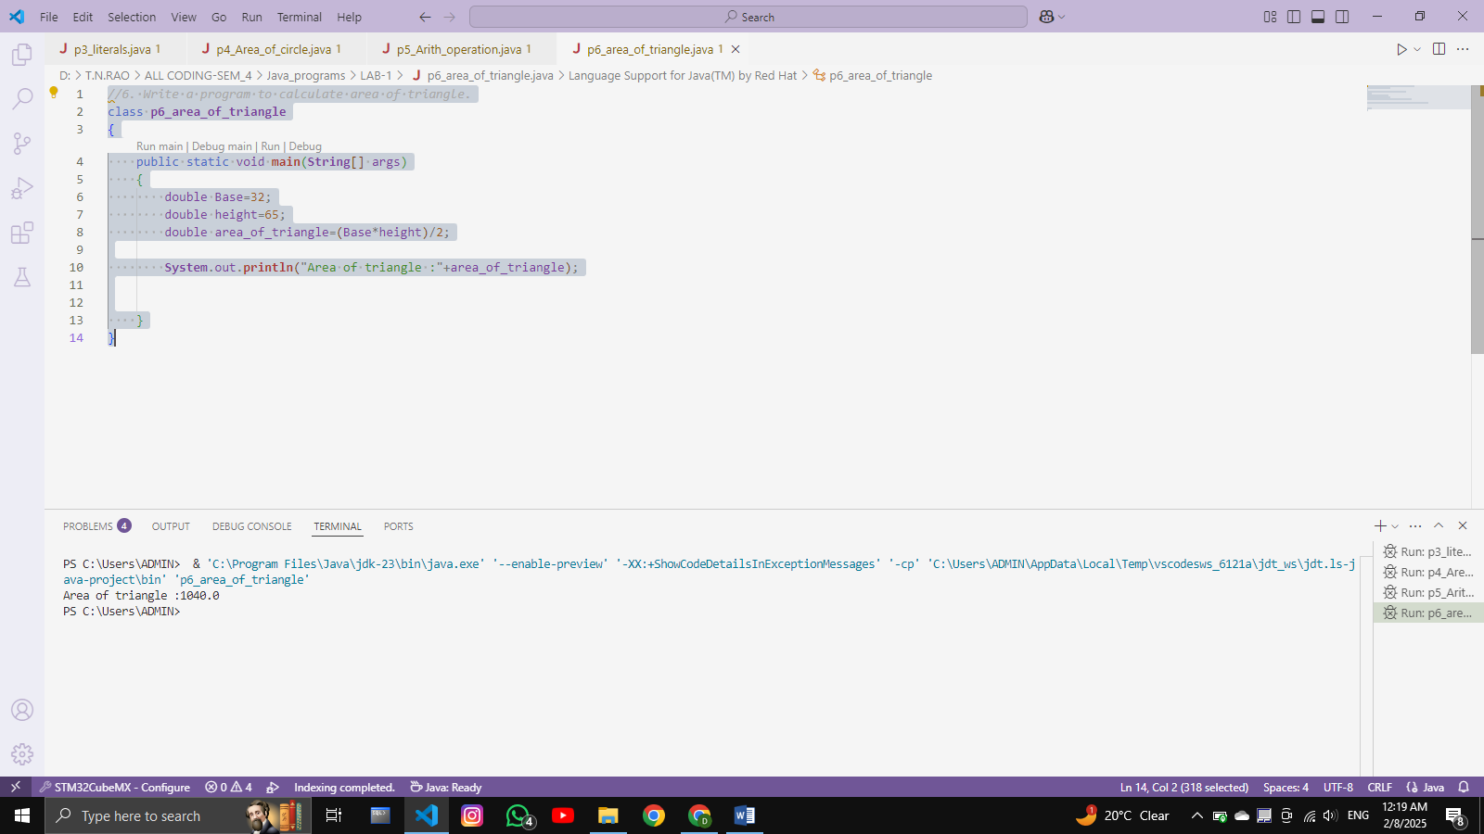

7. Write a program to perform following arithmetic expression.

a. 10*10/5+3-1*4/2 .

*/*7. Write a program to perform following arithmetic expression.*

*a. 10*10/5+3-1*4/2*/*

class **p7_arith_tast_operation**

{

    public static void **main**(**String**[] args)

    {

        double task=(10*10/5+3-1*4/2);

**System**.out.**println**("OPERATION:"+task);

    }

}

# OUTPUT :

______________________________________________________________________________________________________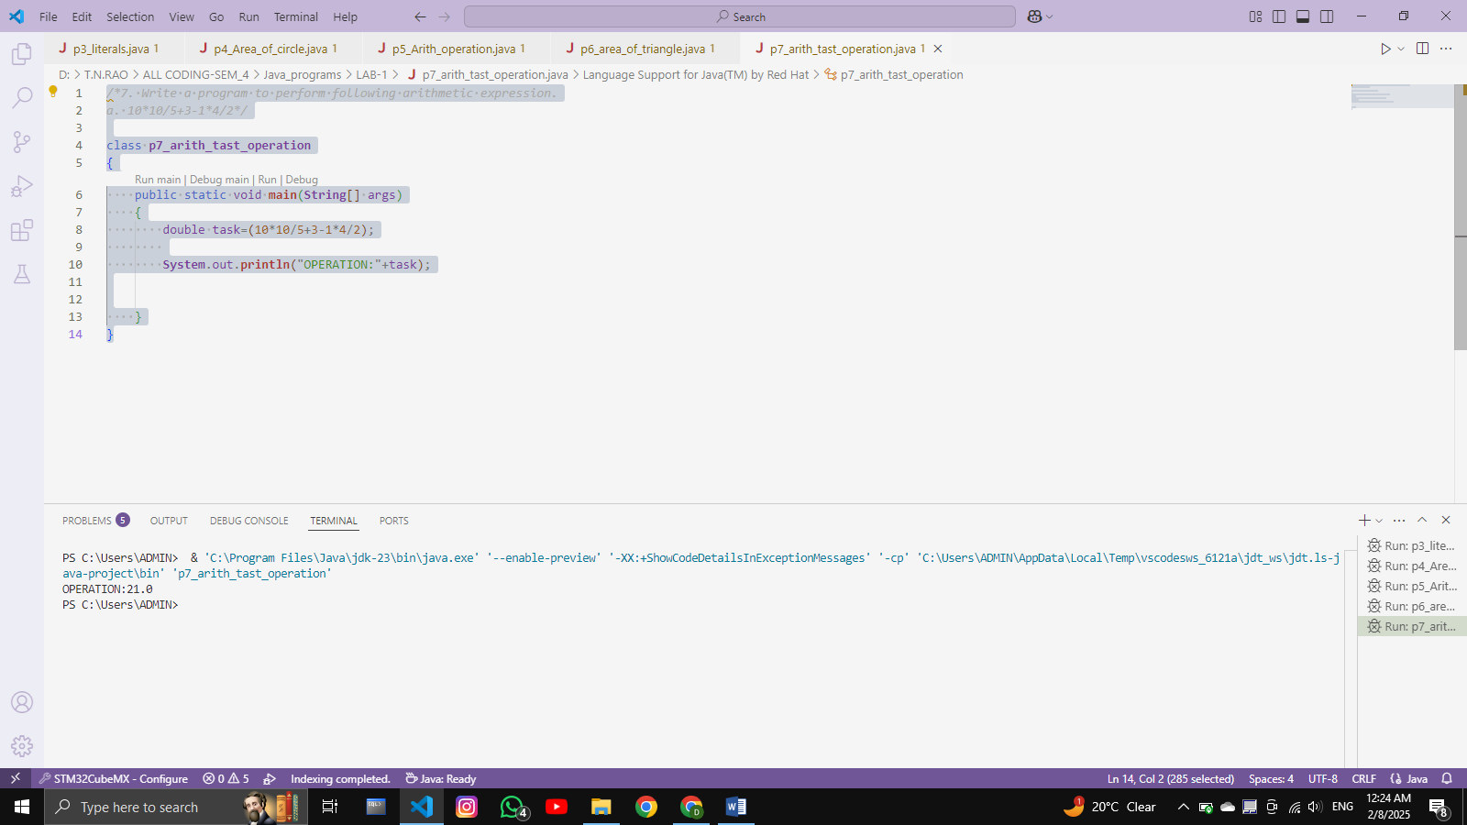

8. Write a program to check whether the number is positive or negative or zero.

CODE:

*//8. Write a program to check whether the number is positive or negative or zero.*

public class **p8_pos_negative_value** {

    public static void **main**(**String**[] args) {

        int value=10;

*// int vlaue=-2;*

*//int value=0;*

        if(value<0)

**System**.out.**println**("Value is negative");

            else if(value>0)

**System**.out.**println**("Value is positive");

            else

**System**.out.**println**("Value is Zero");

    }

}

# OUTPUT :

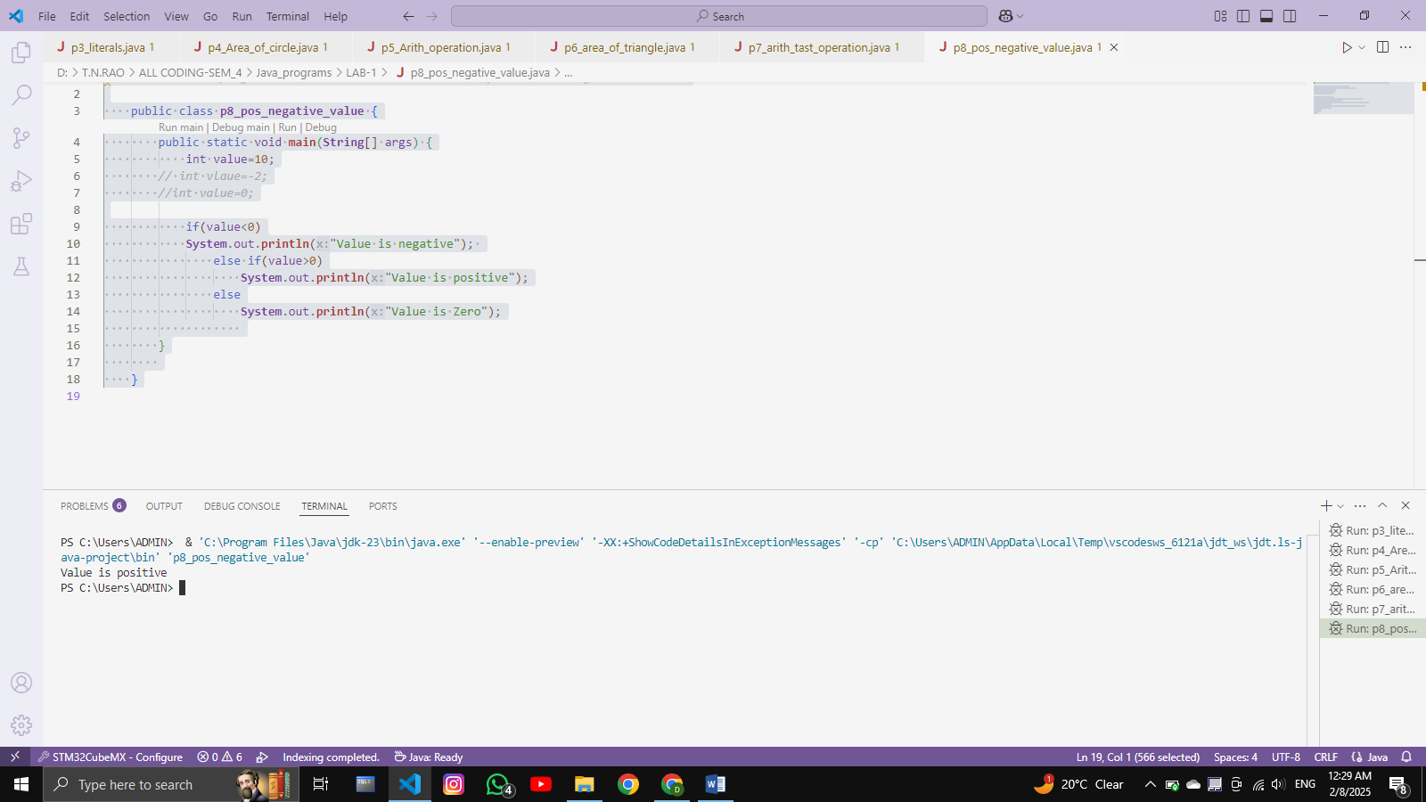

______________________________________________________________________________________________________

9. Write a program that takes a number (1-7) and prints the corresponding day of the

week using a switch statement.

CODE :

*//9. Write a program that takes a number (1-7) and prints the corresponding day of the*

*//week using a switch statement.*

class **p9_switch_statements**

{

    public static void **main**(**String**[] args)

    {

       int day;

       switch (day=4) {

               case 1:

**System**.out.**println**("Today day is Sunday");

               break;

               case 2:

**System**.out.**println**("Today day is Monday");

               break;

               case 3:

**System**.out.**println**("Today day is Tuesday");

               break;

               case 4:

**System**.out.**println**("Today day is Thirsday");

               break;

               case 5:

**System**.out.**println**("Today day is Friday");

               break;

               case 6:

**System**.out.**println**("Today day is saturday");

               break;

               default:

**System**.out.**println**("Number is wrong please enter 1-6 any number");

       }

    }

}

# OUTPUT :

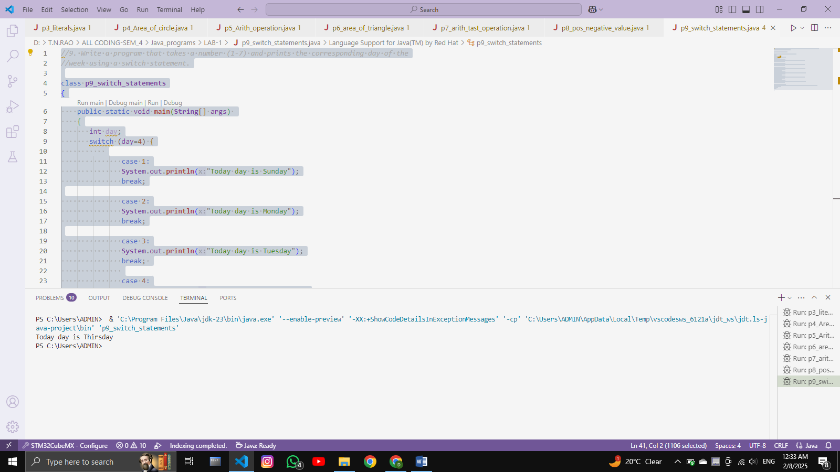

10. Write a program to print 1 to 100 number using do...while loop.

CODE :

*//10. Write a program to print 1 to 100 number using do...while loop.*

class **p10_do_while**

{

    public static void **main**(**String**[] args) {

        int Number=1;

        do{

**System**.out.**println**(Number);

            Number++;

        }

        while(Number<=100);

    }

}

# OUTPUT :

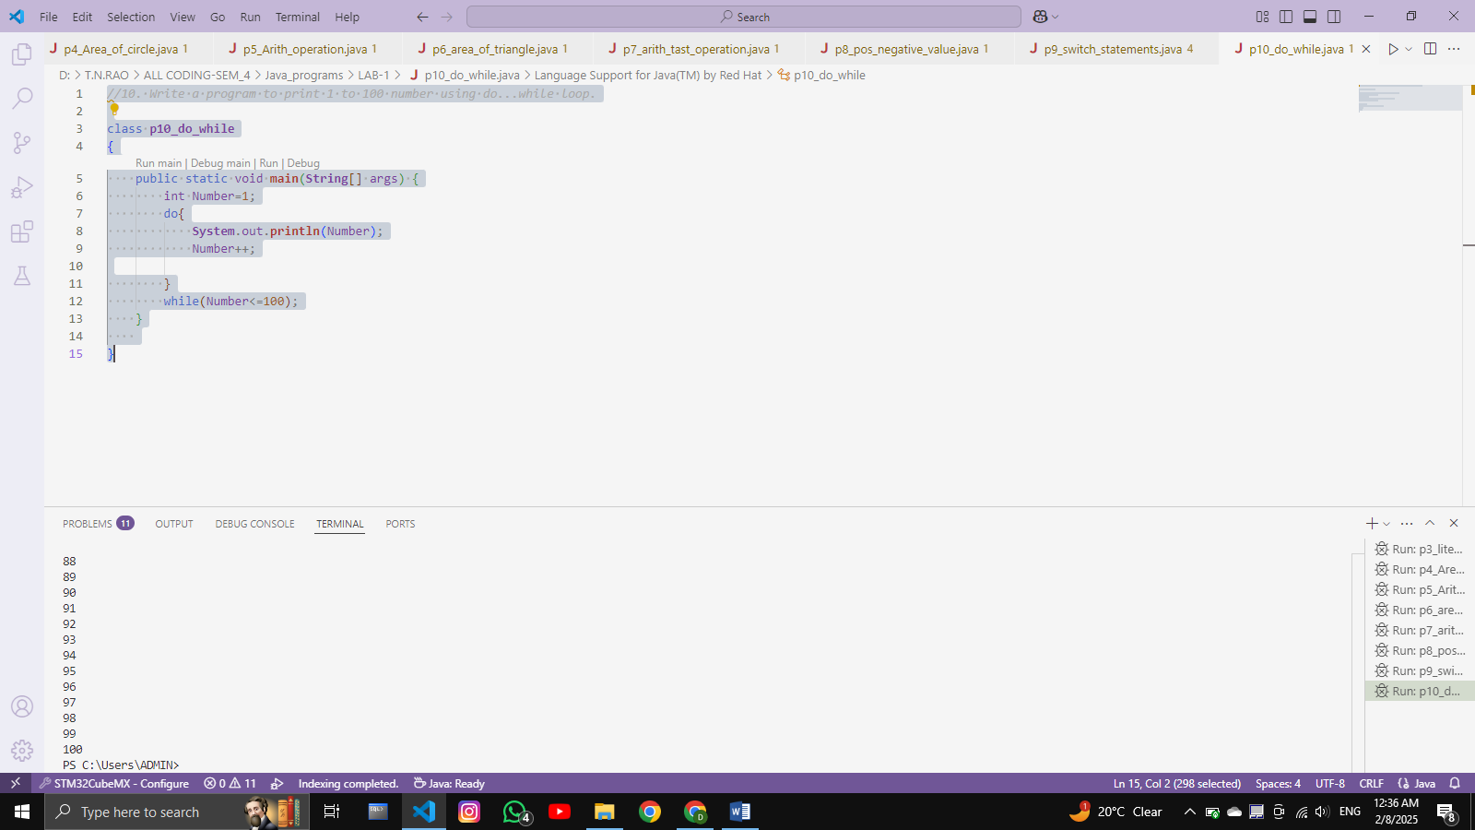

11. Write a program to print following pattern.

________________________________________________________________________________

A. C. B.

1 A A

12 ABA BB

123 ABCA CCC

1234 ABCDA DDDD

12345 ABCDEA EEEEE

CODE :

*/*11. Write a program to print following pattern.*

A

1

12

123

1234

12345 */

class **p11_pattern1**{

    public static void **main**(**String**[] args)

    {

      for(int i=1;i<=6;i++){

       for(int j=1;j<i;j++){

**System**.out.**print**(j);

      }

**System**.out.**println**("");

    }

}

}

OUTPUT :

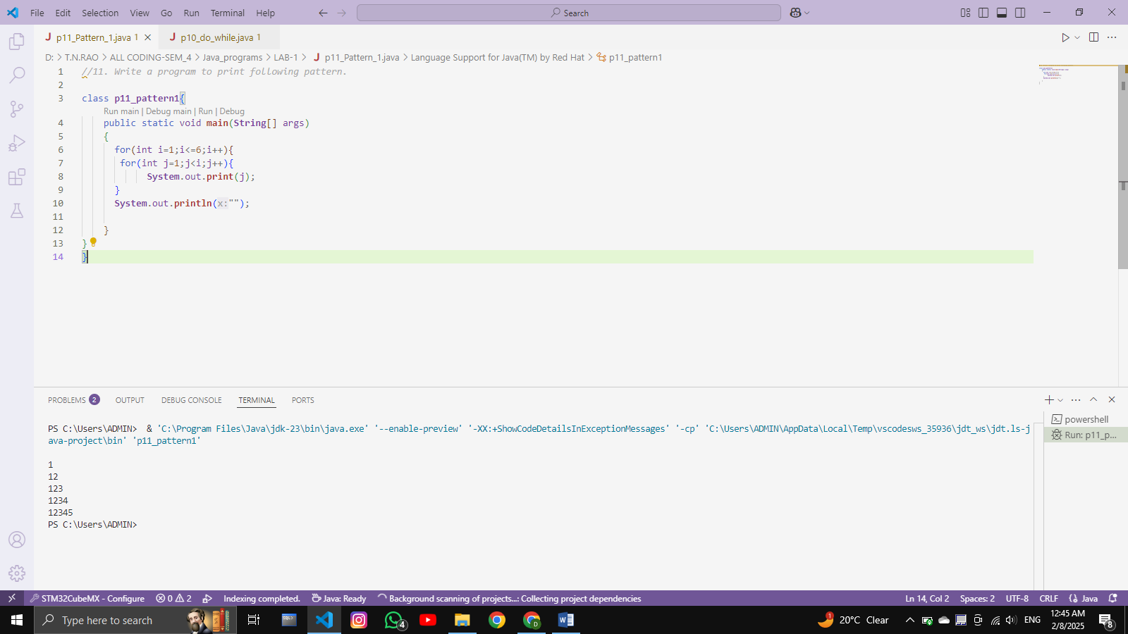

B

A

BB

CCC

DDDD

EEEEE

CODE :

class **p11_Pattern_2**{

    public static void **main**(**String**[] args){

      char a='A';

      for(int i=1;i<=5;i++){

**System**.out.**print**(a);

       for(int j=1;j<i;j++){

**System**.out.**print**(a);

         } a++;

**System**.out.**println**();

       }

    }

}

# OUTPUT :

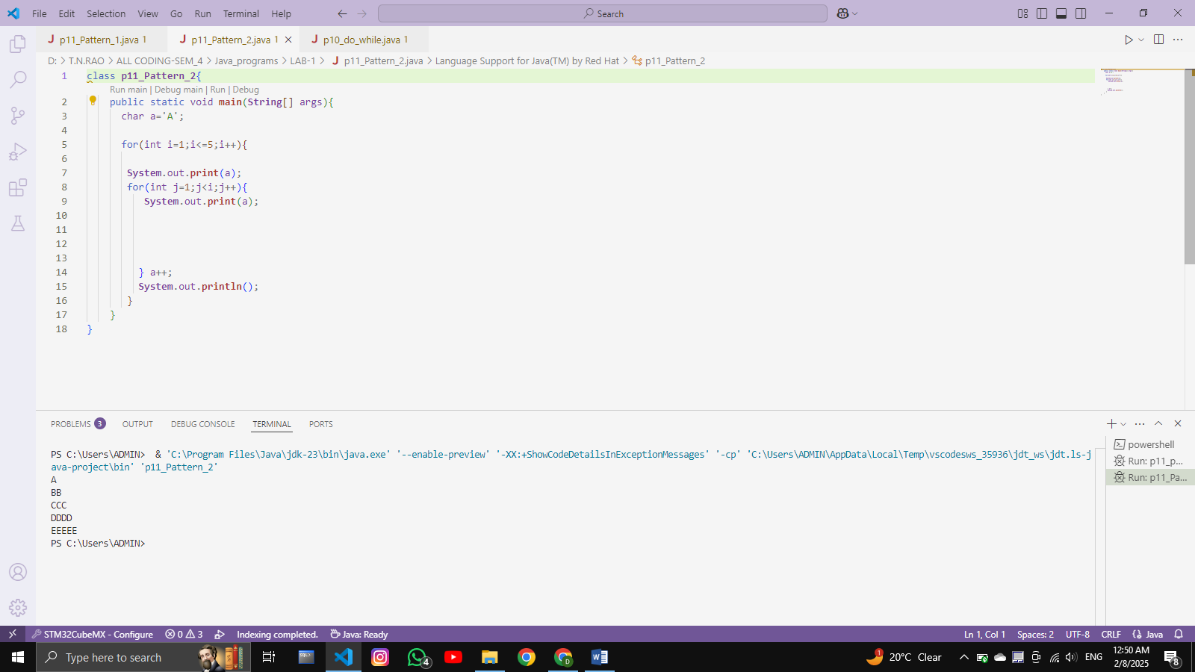

C

A

ABA

ABCA

ABCDA

ABCDEA

CODE :

public class **p11_Pattern_3**{

    public static void **main**(**String**[] args) {

        int n = 5; *// Number of lines*

        for (int i = 0; i < n; i++) {

*// Print the first part of the pattern (A, AB, ABC, etc.)*

            for (int j = 0; j <= i; j++) {

**System**.out.**print**((char) ('A' + j));

            }

*// Print the last 'A'*

            if (i > 0) {

**System**.out.**print**('A');

            }

**System**.out.**println**(); *// Move to the next line*

        }

            }

        }

# OUTPUT :

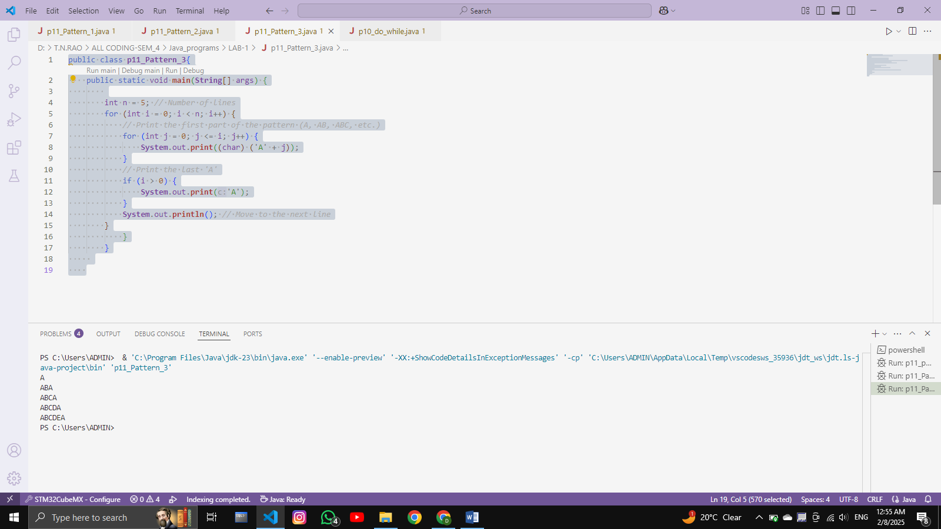

______________________________________________________________________________________________________

# **THE END**